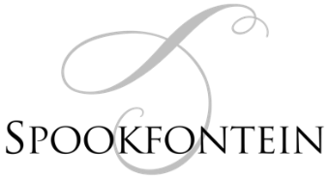
Snack Options
Oysters
served with Lemon, tabasco, salt and pepper
R30 each

Olives & Crackers
R55

Cheese & Olives
served with Crackers & Onion Marmalade
R125

Charcuterie
Chorizo, Smoked- and Black Forrest Ham, Smoked Game and Salami
Served with Crackers, Olives & beetroot relish
R145
Add a cheese-R40 each

PET NAT R60 | Sauvignon Blanc R50 | Full Moon R60
Chardonnay R75 | Rosé R40 | Pinot Noir R75
Syrah R60 | Merlot R50 | Cabernet Sauvignon R60
Cabernet Franc R60 | Phantom R70 | Dry Red R40
 | Cape Ruby R40
Wine By the glass




@SpookfonteinWines |  | @Spookfontein

